WELCOME TO A Level PSYCHOLOGY
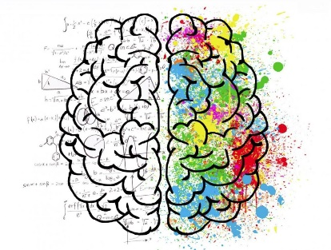

Welcome!
The pack is designed to introduce you to A level Psychology ready for KC Sixth.
Textbooks
Textbooks are essential to succeed on the course. Here are some of the recommended ones:
We do have an online copy of the 1st book (Green haired girl). You will be given the codes to access in September but it is always good to have a physical copy!
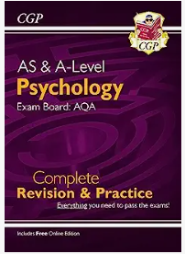
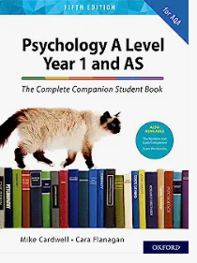

Recommended Viewing
- A Beautiful Mind (2001): Ron Howard's brilliant film not only educates the viewer about schizophrenia but ingeniously brings the viewer to empathize - and to a degree - experience the confusing pain of schizophrenia, as portrayed by Russell Crowe as mathematics genius, John Nash.
- One Flew over the Cuckoo's Nest (1975): For a generation of students new to psychology, this film offers a slice of their profession's history, as seen in the barbaric and controlling treatment of patients at a psychiatric hospital.
- To Kill a Mockingbird (1962): Regarded by the American Film Institute as depicting the greatest hero in American cinema, Atticus Finch (Gregory Peck), an attorney who defends a Black man accused of rape. Heroes and exemplars portrayed in films can serve as powerful motivators in treatment.
- The Shawshank Redemption (1994): one of the most popular films ever made, perhaps due to the ease an individual can relate to the story of a man wrongfully imprisoned but never giving up hope. Since most clients seeking psychology services are seeking hope, this is a great film to recommend as a treatment adjunct.
Recommended Reading
- The Lucifer Effect-Zimbardo
- The Social Animal
- Mark Haddon- The Curious Incident of the Dog in the Night Time
- Oliver Sacks- The Man who mistook his wife for a hat
- Putwain and Sammons- Psychology and Crime
- Judith Rapoport- The boy who couldn’t stop washing
Useful Websites:
- http://psychcentral.com
- https://www.psychologytoday.com/
- http://www.spring.org.uk/
- http://www.bbc.co.uk/science/humanbody/mind/index.shtml
- http://digest.bps.org.uk/
- https://www.ted.com/topics/psychology
Summer Task
In preparation for the Social Influence Unit, research the following experiments
- Asch (1951)
- Milgram (1963)
- Zimbardo (1969)
Research what happened in the experiment and come up with an overall conclusion.
In preparation for the Psychopathology unit, research the following psychological disorders.
- OCD
- Depression
- Phobias
- Schizophrenia
Find out their causes, symptoms and current treatments.
Have a great summer and I look forward to seeing you in September!
Catherine (cw@kendal.ac.uk)

