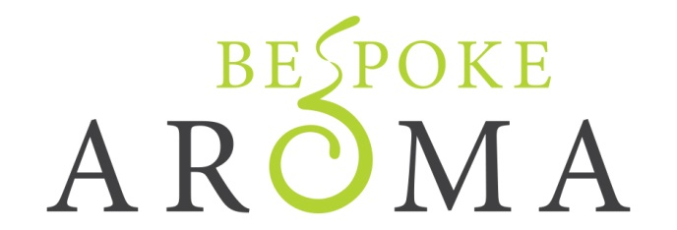

Sensitive Skin Facial Kit Order Form
Kits are £65 which includes postage and packaging
Kit contains one of each of the following:
100ml Facial Cleansing Cream
100ml Facial Cleansing Balm
100ml Facial Scrub
100ml Floral Water Toner
100ml Facial Massage Balm
100ml Gel Mask
30ml Facial Oil
100ml Facial Moisturiser
30ml Eye Serum Cream
To order please email joevans@bespokearoma.co.uk with your name and address for delivery. An invoice with details of how to make a payment will be emailed to you.
Please allow up to 3 weeks for delivery once order has been paid for.
Thank you for your order

