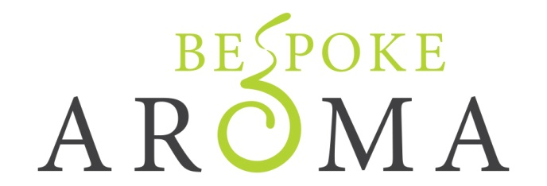

Pre-Blended Massage Oil Kit Order Form
Kits are £40 which includes postage and packaging
Kit contains one of each of the following:
100ml Relaxing Body Oil
100ml Balancing Body Oil
100ml Uplifting Body Oil
100ml Stimulating Body Oil
100ml Anti-Cellulite Body Oil
To order please email joevans@bespokearoma.co.uk with your name and address for delivery. An invoice with details of how to make a payment will be emailed to you.
Please allow up to 3 weeks for delivery once order has been paid for.
Thank you for your order

