Kukri are a global bespoke sportswear manufacturer supporting over 100 sports, for schools, universities and professional teams, providing clubs with a choice of designs, an individual identity, whilst enhancing their pride in their official sportswear.
They are the official kit suppliers for many high profile partners, including, Team England, Lancashire County Cricket Club and Loughborough University, plus many more.

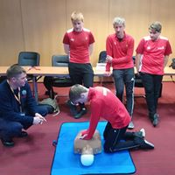
We are partnering with our kit supplier Kukri where you will be able to order kit online and have it ordered to home for a delivery charge.
At enrolment you will be able to try the kit for size and then order online.
The cost of the Sport Pack will be in the region of £150 (tbc) and will contain a ¼ zip top, padded jacket, t-shirt and trousers / leggings. Although there will be extras you can order such as the Winter Pack (perfect for our Cumbrian weather!)
