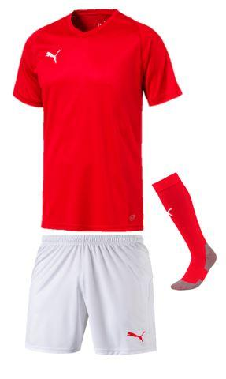
Puma designs, sources, and markets football-related apparel, footwear, and equipment. Its products are sold in over 90 countries worldwide.
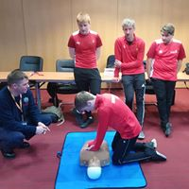
We are partnering with our local kit supplier 17Sport where you will be able to order kit online and have it ordered to come to college or to home for a small charge.
At enrolment you will be able to try the kit for size and then order online.
The cost of the Sport Pack will be in the region of £99 (tbc) and will contain a ¼ zip top, rain jacket, t-shirt and shorts. Although there will be extras you can order such as the Winter Pack (perfect for our Cumbrian weather!)
