Geology Course Information
Below is a list of content related to A Level Geology that will give you a feel for the subject before you begin your studies.
Books
The list is by no means exhaustive!
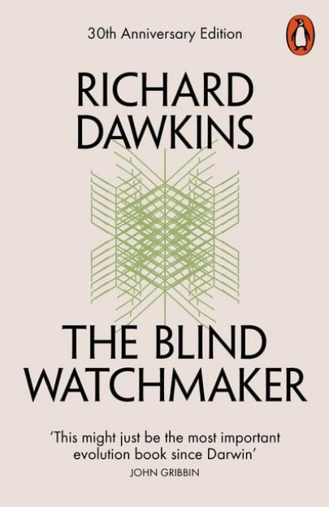 | 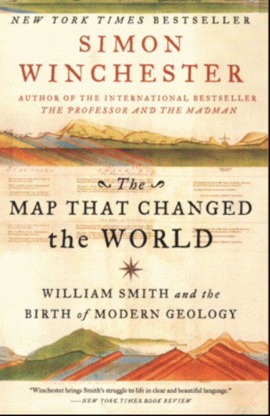 | 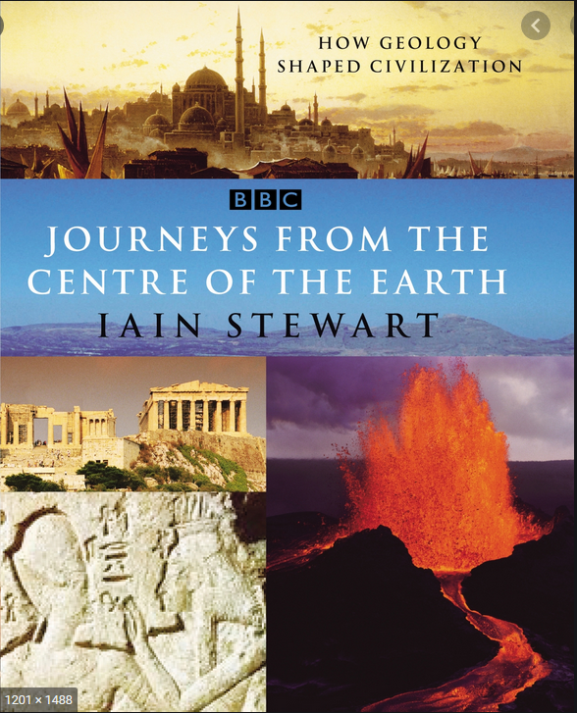
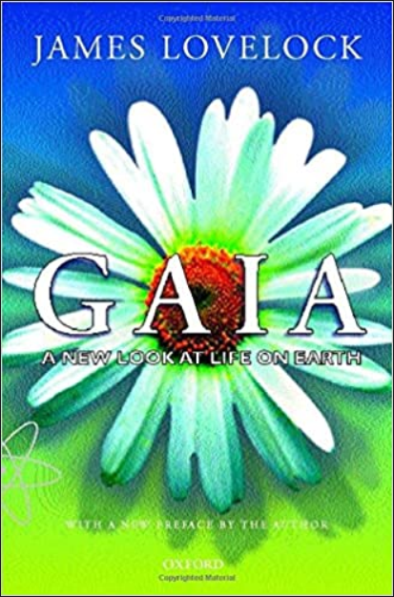 | 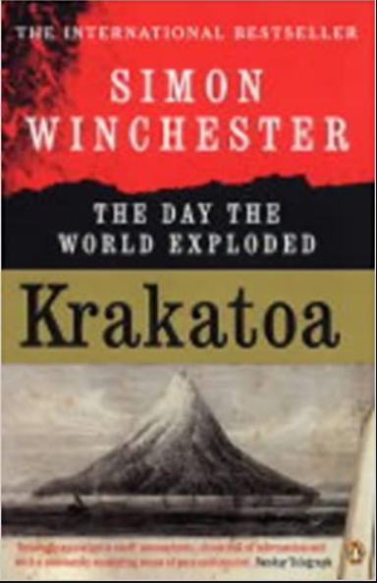 | 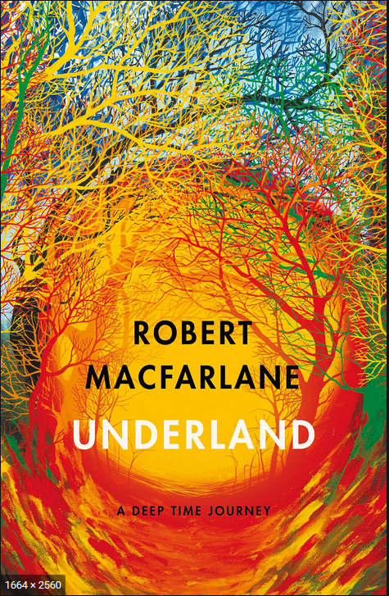
Books
- The Blind Watchmaker (1986) by Richard Dawkins
This book, The Blind Watchmaker, was originally published in 1987 and was reissued as a new edition in 1996. In it, Dawkins's objective is to counter the current arguments against Darwin's theory of evolution and, specifically, to educate the public in how the theory of evolution by natural selection explains the complexity and beauty of design of living organisms found in the world today.The title of the book and the initial motif is a famous treatise by the eighteenth-century theologian William Paley whose contention is, as is also that of many fundamental Christian groups and the so-called creationists, that the creation of life on planet Earth is the work of an Intelligent Designer.
- The Map that Changed the World (2002) by Simon Winchester
The Map that Changed the World is a book by Simon Winchester about English geologist William Smith and his great achievement, the first geological map of England and Wales. His pivotal insights were that each local sequence of rock strata was a subsequence of a single universal sequence of strata and that these rock strata could be distinguished and traced for great distances by means of embedded fossilized organisms. The book describes the social, economic or industrial context for Smith's insights and work, such as the importance of coal mining and the transport of coal by means of canals, both of which were a stimulus to the study of geology and the means whereby Smith supported his research. Land owners wished to know if coal might be found on their holdings. Canal planning and construction depended on understanding the rock and soil along its route.
- Journeys from the Centre of the Earth (2004) by Iain Stewart
Forward-thinking geologist and television presenter Dr Iain Stewart, uncovers the hidden Mediterranean and brings a fresh and dramatic eye to geology to show just why it is that geology should be restored to its rightful place as the grandfather of sciences. From earthquakes and volcanoes to Roman architecture and cuisine, Iain discovers just how geology has shaped our lives and how we can expect it to affect us in years to come.
- Gaia (2000) by James Lovelock
James Lovelock started to write this book in Ireland 1974 against the backdrop of the Cold War and the start of the environmental movement, a legacy bequeathed by Rachel Carson (1907-1964). His involvement in NASA’s planetary exploration programme to investigate life on Mars spurred him on to ask the question: what defines life? This book, which has been corrected and re-published with a new preface, explains his thought process and provides the evidence for the existence of Gaia. His evidence for Gaia begins with the history and evolution of the earth, and how through feedback cycles equilibriums were established. It is a global disequilibrium that keeps energy in flux and because of this Gaia is a self-regulating system keeping in check the components and processes that could ultimately be disastrous for life.

- Krakatoa: the Day the World Exploded (2003) by Simon Winchester
The legendary annihilation in 1883 of the volcano-island of Krakatoa - the name has since become a byword for a cataclysmic disaster - was followed by an immense tsunami that killed nearly forty thousand people. Beyond the purely physical horrors of an event that has only very recently been properly understood, the eruption changed the world in more ways than could possibly be imagined. Dust swirled round die planet for years, causing temperatures to plummet and sunsets to turn vivid with lurid and unsettling displays of light. The effects of the immense waves were felt as far away as France. Most significant of all -- in view of today's new political climate -- the eruption helped to trigger in Java a wave of murderous anti-Western militancy among fundamentalist Muslims: one of the first outbreaks of Islamic-inspired killings anywhere. Simon Winchester's long experience in the world wandering as well as his knowledge of history and geology give us an entirely new perspective on this fascinating and iconic event as he brings it telling back to life.
- Underland: A Deep Time Journey (2019) by Robert Macfarlane
In Underland, Robert MacFarlane travels to underground, often forgotten places in an attempt to understanding humans' impact on the earth and our relationship with landscape. The book explores underlands as they exist physically, in myth, history and in literature. MacFarlane draws on mythology and literature as well as a great deal of contemporary science to illuminate the places where he travels.
Ideas for summer fieldwork:
- Explore the countryside (e.g. the Lake District and Yorkshire Dales) to see if you can identify any features related to glaciers or hazards.
- Engage with a range of Geographic Information Systems (GIS). Can you find your house on Google Earth? Can you find an example of a drumlin? Which areas in a city look like they are in need of regeneration?
- Try hunting for fossils, perhaps in the limestone in Cumbria, Yorkshire and Lancashire.
- Begin ca mineral collection. What are the uses of the minerals and what are their chemical constituents?
Required reading:
• OCR Geology for A Level and AS. ISBN 978-1-911208-14-3

Documentaries:
- Men of Rock https://www.youtube.com/watch?v=FYfuI2uZLmg
- Birth of Britain https://www.youtube.com/watch?v=aBWJZBdWug0
- Planet Oil https://www.youtube.com/watch?v=j8edLAVHKuo
Films
Can you separate geological fact from fiction in the films below?
- Jurassic Park
- Dante’s Peak
- Journey to the Centre of the Earth
- The Wave
- Ring of Fire
- Volcano
Websites
Explore the websites below and use them to get a feel of the subject.
United States Geological Survey Volcano Monitoring Programme https://volcanoes.usgs.gov/index.html
Antarctic Glaciers http://www.antarcticglaciers.org/
British Geological Survey Map viewer http://mapapps.bgs.ac.uk/geologyofbritain/home.html?
Ordnance Survey Map Viewer https://osmaps.ordnancesurvey.co.uk/54.32150,-2.75458,11
National Geographic https://www.nationalgeographic.com/
The Geological Society https://www.geolsoc.org.uk/Geology-Career-Pathways/School/Studying-Geology-at-School

